**Day-03 API Integration Report**

**Fetching Data from Sanity API in a Next.js Project**

**Introduction:**

In modern web development, content management systems (CMS) like Sanity provide a headless CMS solution, allowing developers to fetch and display content dynamically via APIs. This report details the process of fetching data from the **Sanity API** in a **Next.js** application, including how to set up Sanity, query data, and display it within a React component.  
  
**Adjustments in schemas:**

Color, Status and Inventory fields updated, as I didn’t add them yesterday but today updated the fields according to provided API

**Sanity CMS Fields:**

**API INTEGRATION PROCESS:**

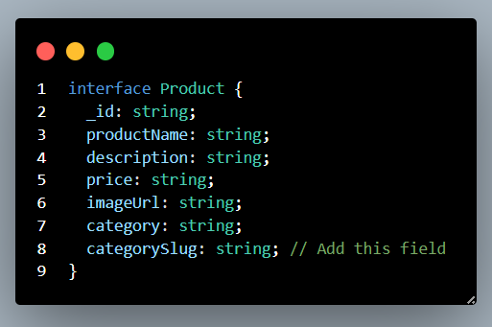

**Data Displayed in Front-end:**



**That’s how I completed Today’s task of Day-03 of Hackathon-03.**

**Created by WAQAR AHMED**

**Sunday 2-5 PM.**